Press Release futronic GmbH
futronic makes vacuum process visible
Vacuum process control (VPC) detects manufacturing problems before they occur

Tettnang, 25 February 2022 – Only last summer, futronic launched the VCS (Vacuum Control System) in the market, a reject system that enables manufacturing problems occurring during the vacuum process to be detected. The automation specialists from Lake Constance are now introducing a more advanced version: the new VPC (Vacuum Process Control System) makes processes visible in the vacuum cycles and records pressure curves and errors precisely. The wear condition of filters, valves and blow moulds, for example, can be represented in this way, so that the VPC detects manufacturing problems at an early stage before they have a chance to occur. The system can optionally be integrated into the FMT24S IS machine control system or retrofitted to existing equipment and will also be available in a standalone version.

Quality has to be controlled, and the manufacturing processes in container glass production are no exception. The principle is invariably the same: sensors identify faulty containers automatically and reliably, and those containers are then accurately removed by the reject unit. futronic’s VCS works this way too: sensors measure the vacuum that is applied to each job and compare the value with a setpoint which is individually defined for each section. If a discrepancy is determined, the inferior article is ejected from the conveyor belt. The VCS thus makes a significant contribution to improving the quality of both the products themselves and the manufacturing process.

Quality-sensitive vacuum processes
But wouldn’t it be even better to detect errors before they have a chance to occur? “Of course”, says Florian Pawlowski, Product Manager at futronic, “that has to be the goal”. That’s why 37 year-old Pawlowski and his colleagues have held many discussions with machine operators, production managers and technicians ever since the VCS first appeared in the market. Their verdict: the majority of manufacturing processes and sequences in an IS machine are measured in even the most inaccessible corners, and monitored and controlled from the furnace to the lehr. However, the vacuum process in the blow mould has so far taken place largely in the dark. “Our conversations showed that the vacuum process is very quality-sensitive”, Pawlowski explains. Both the testing machines and the VCS can do no more than react by rejecting faulty products. Even so, it’s not unknown for Quality Assurance to overlook manufacturing problems like so-called “bird swing”, especially where very small bottles are concerned. “Bird swing has extremely sharp edges and you can easily get hurt”, he reports. In addition to this, it could break off, so that glass chips land on the pallet or maybe fall into other containers – with potentially fatal consequences. And in order to clear the problem, the machine generally has to be stopped and the packed pallets re-sorted at considerable expense.

Important input from valued development partners
And so the specialists at futronic set about further developing the VCS – hoping to close one of the last remaining quality monitoring gaps in container glass production. Important input was received from technicians at Heye International, a manufacturer of production equipment and for many years an important business and development partner of the Tettnang firm as well as the licensor for this technical process. Other longstanding futronic customers likewise collaborated on the project.

VPC enables proactive maintenance
“The idea was to bring light into the darkness, in other words to make the entire vacuum process visible.” To do that requires sensors that supply key data separately for each section. Pressure or the vacuum in the blow moulds are particularly relevant parameters, for instance. The increase or decrease in pressure, the maximum values and the duration of the vacuum cycles are also measured, as are the response times of the vacuum valves. All data is visualised on the operator terminal and the complete vacuum process is represented in this way – practically in real time! “Machine operators can keep a constant eye on the functionality and wear condition of the valves, the filters and the blow mould itself in this way”, Pawlowski adds. “They can react quickly and correct any malfunctions before they result in defects, without having to interrupt production.”

Standalone version allows seamless integration
The VPC option is due to become available in April for all IS machines equipped with futronic’s proven FMT24S machine control system. It can furthermore be retrofitted to any existing equipment featuring an FMT24S control system. The VPC will be implemented as a seamless add-on for the FMT24S’s OT software. futronic can also supply the VPC in a standalone version with a separate interface for integration into the control infrastructure of other manufacturers.

More information: www.futronic.de

Photos

futronic_VacuumControlSystem.jpg

Caption: Compact design: the VPC can optionally be integrated into IS machines or retrofitted to existing equipment and is also available in a standalone version. (futronic / Marco Mehl)

futronic_VPC-Historie.jpg
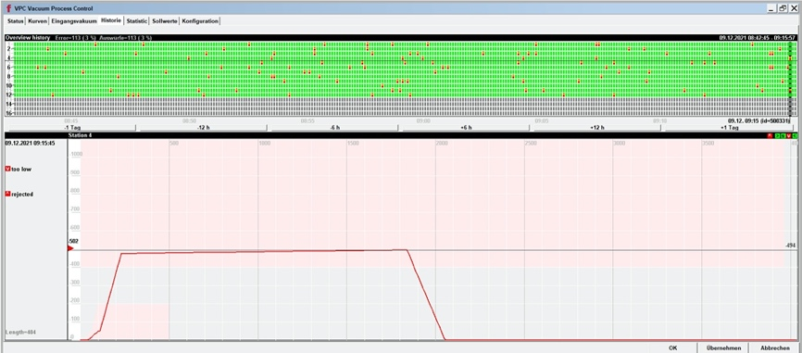
Caption: Visualisation: the VPC makes the entire vacuum process visible based on the data supplied by the sensors – practically in real time!

futronic_VPC-Sollwerte.jpg
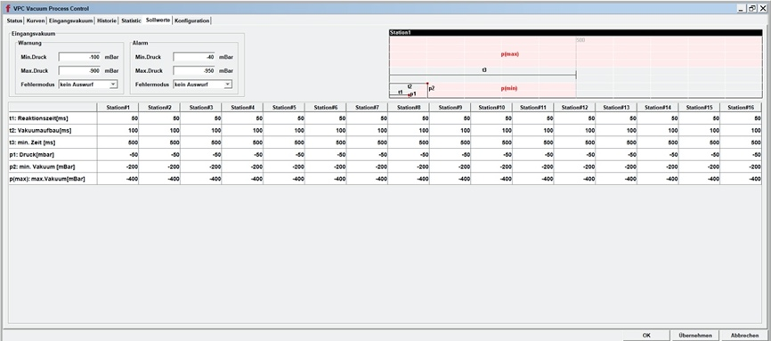
Caption: All information at your fingertips: the VPC also monitors parameters like the response time of the vacuum valve, the increase or decrease in pressure, the maximum values and the duration of the vacuum cycles – separately for each section. The operator can then take immediate action in case of critical deviations from the setpoints.

futronic_Florian Pawlowski.jpg
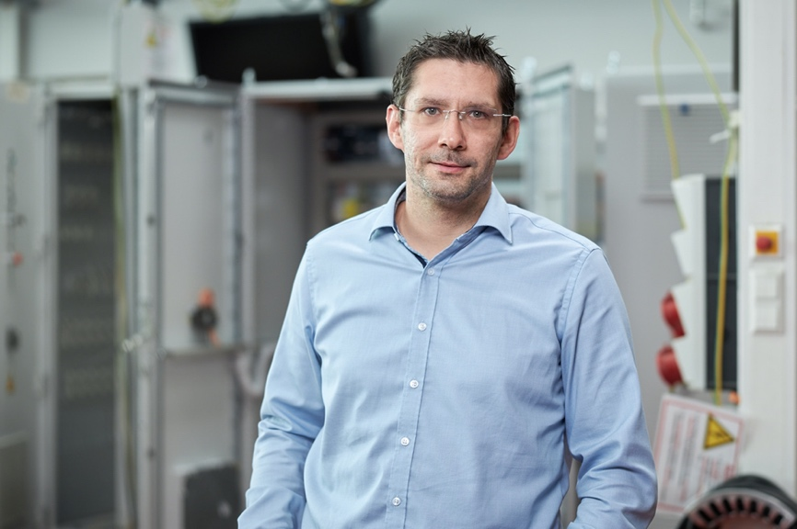
Caption: Florian Pawlowski, Product Manager at futronic

About futronic
futronic GmbH is one of the world’s leading providers of complex automation solutions for plant and equipment manufacturers. The emphasis is on the container glass, tableware, bulk materials, beverage and handling & assembly industries. The company has grown considerably in recent years: a team of around 90 staff currently support some 1000 installations worldwide in the glassmaking industry alone. futronic was established in 1972 and is today a Jetter AG company. Its Managing Directors are Michael Preuss and Christian Benz.

Contacts for editorial queries
futronic Product Management, Florian Pawlowski, +49 7542 5307-631, florian.pawlowksi@futronic.de
futronic Corporate Communications, René Kius, +49 171 1915263, rene.kius@kius-kommunikation.de

